Advance Report

Mohamed moghazy 19100650

Abdelrahman moawad

Our project is built for college system that calculate gpa , add student ,add subject and add staff employee

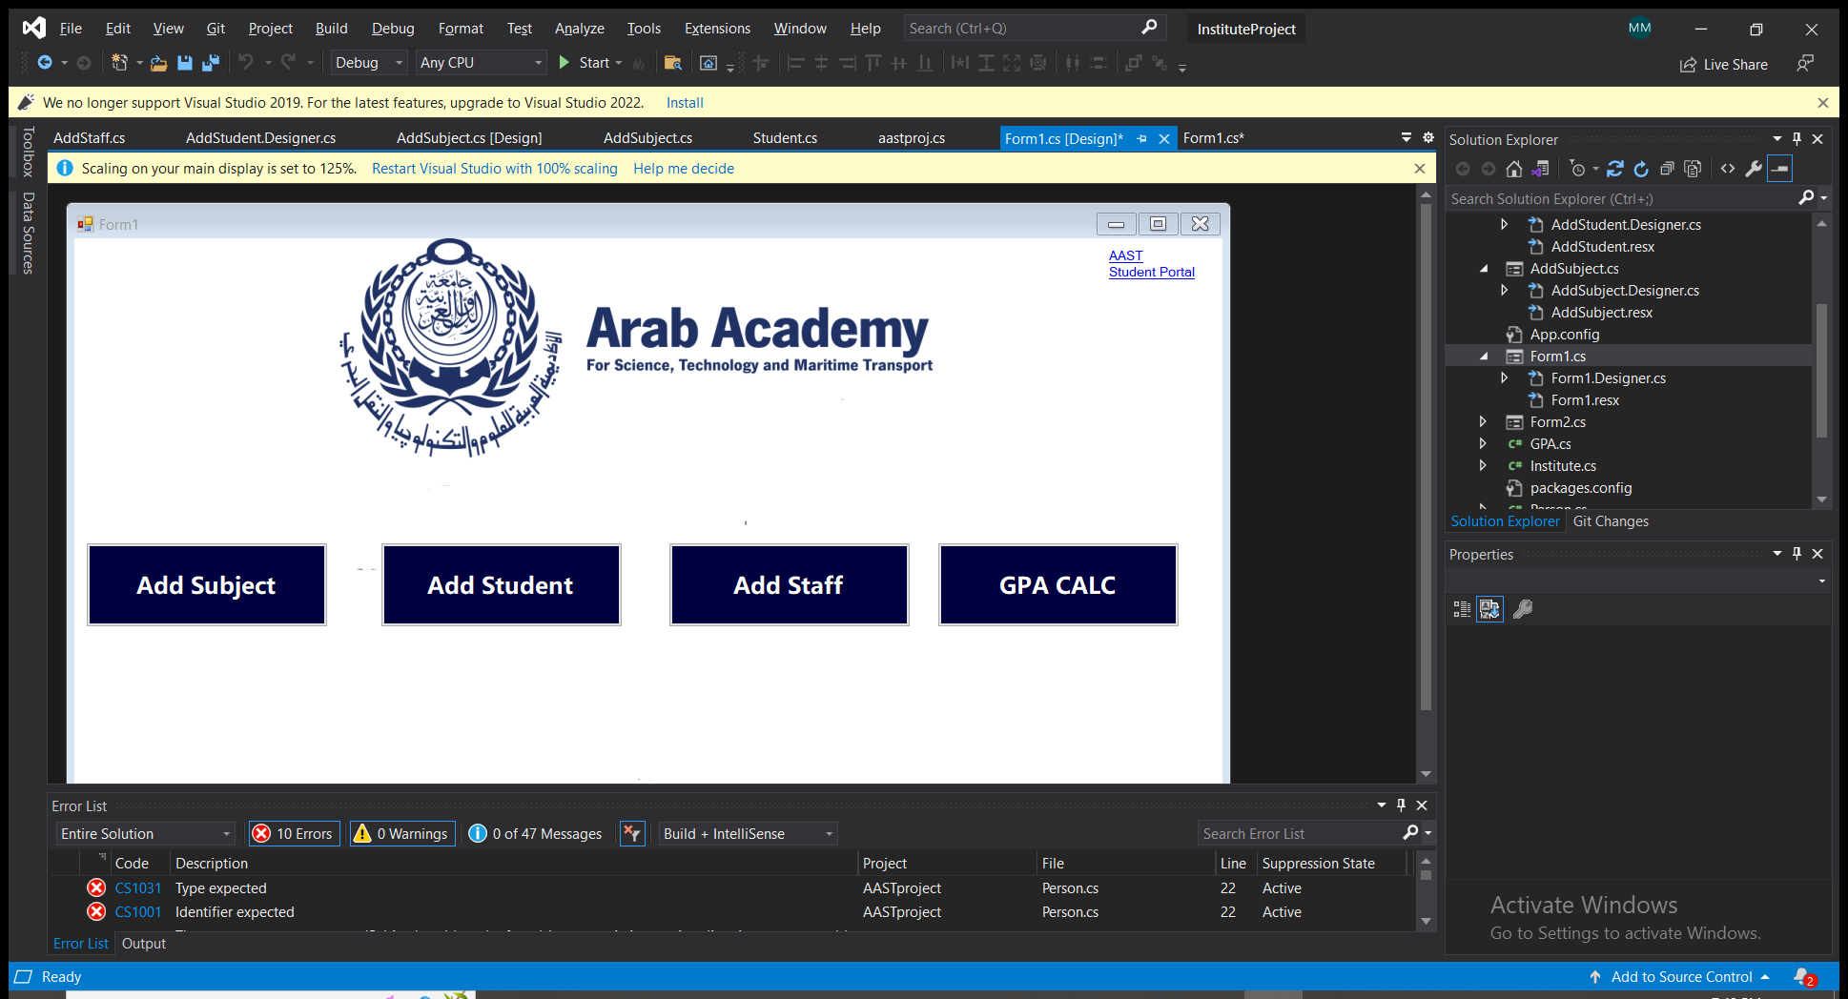

In this form we talk about the main form which have add student that’s we add student to the institute to be regisitred.

Add subject that we add subject to the institute for the students for their courses .Add staff ,to add staff for the courses .

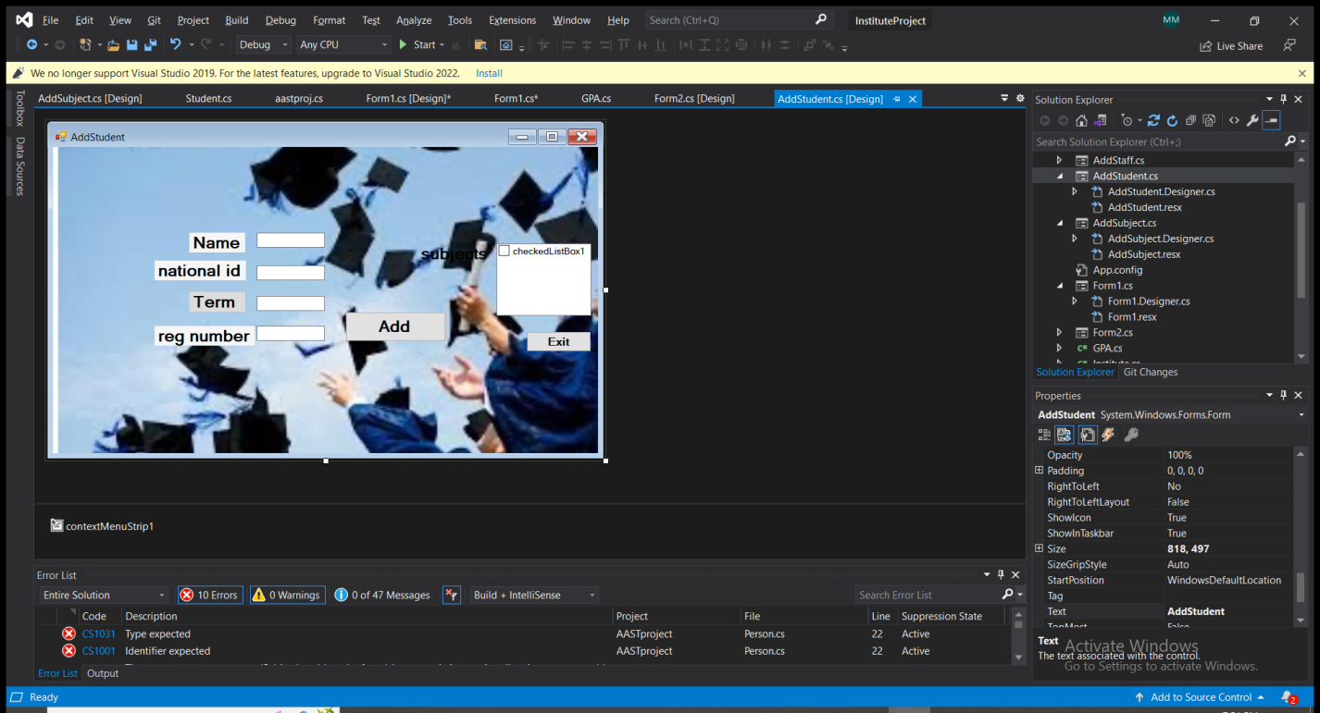

In this form, the user (student) is asked to register and input name, id, term and registration number, the student can also add their subject

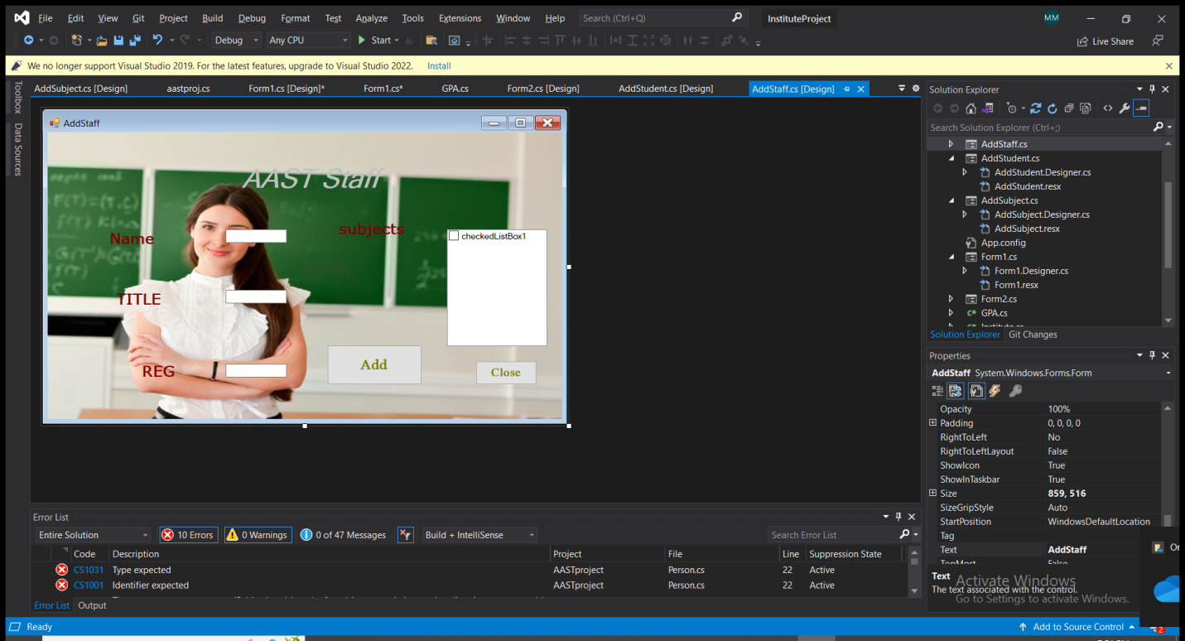

In this form, the user (this time the staff) is asked to register and enter their name, id, position and can also add the subjects they’re teaching.

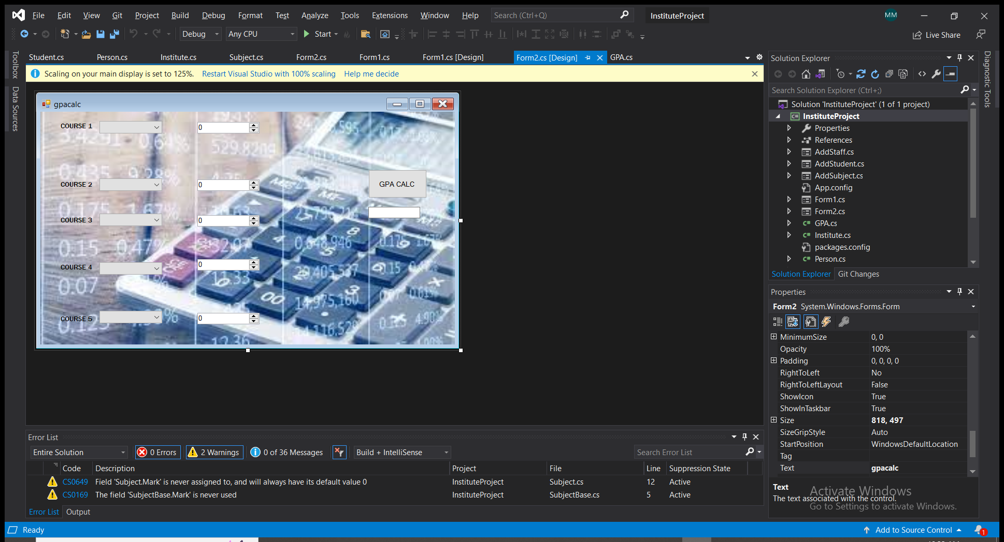

Here we calculate the gpa of the courses that the student takes based on the credit hours of the subjects registered.

We choose the grade depending on the mark out of 100

The final result is the gpa of all courses of this term.

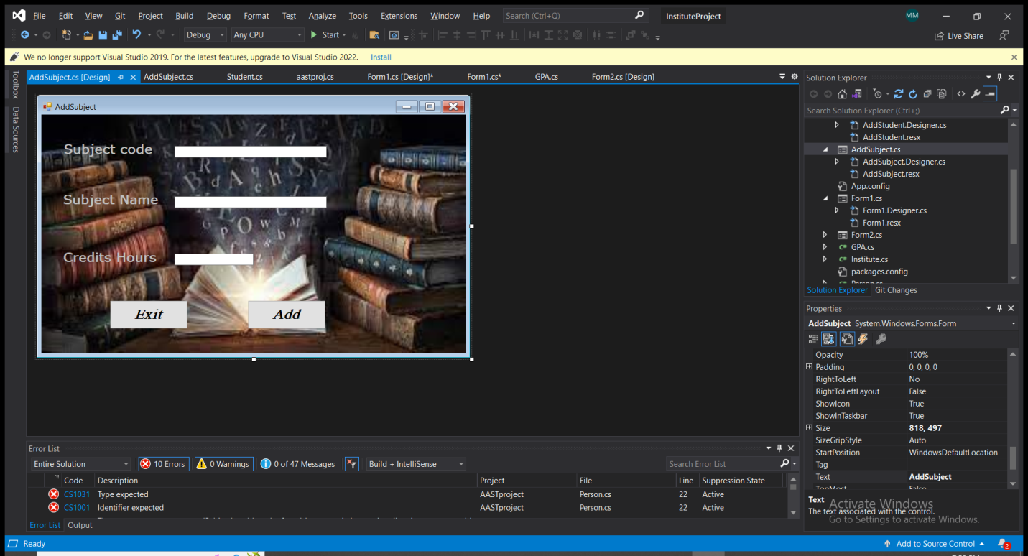

In this form the user (whether they are students or staff) is asked to enter the id of the course and the subject name

|  |
| --- |
| gpa |
| +gpa:double  +mark:int |
| +GradeCalculation() |

|  |
| --- |
| person |
| +name:string  +id:int |
| +Display();  + Student GetStudent();  +Staff GetStaff(); |

|  |
| --- |
| Institute |
| +name:string  +id:int  +address:string |
|  |
| Student | |
| +termid:int  -reg:int | |
| +AddSubject  +GetStudent  +Getstuff | |